Bash Scripting Assignment-02

Environment Setup (Common for All Tasks)

Outcome
Amazon Linux EC2 instance launched, connected via SSH, and Bash-Assignment project directory created successfully.

Objective
Prepare the Amazon Linux EC2 environment required to perform all Bash scripting tasks.

Prerequisites
• AWS Account
• Amazon Linux EC2 Instance
• SSH Key Pair
• Bash Shell
• Sudo Privileges

Step-by-Step Implementation
Step 1: Launch an Amazon Linux EC2 instance.
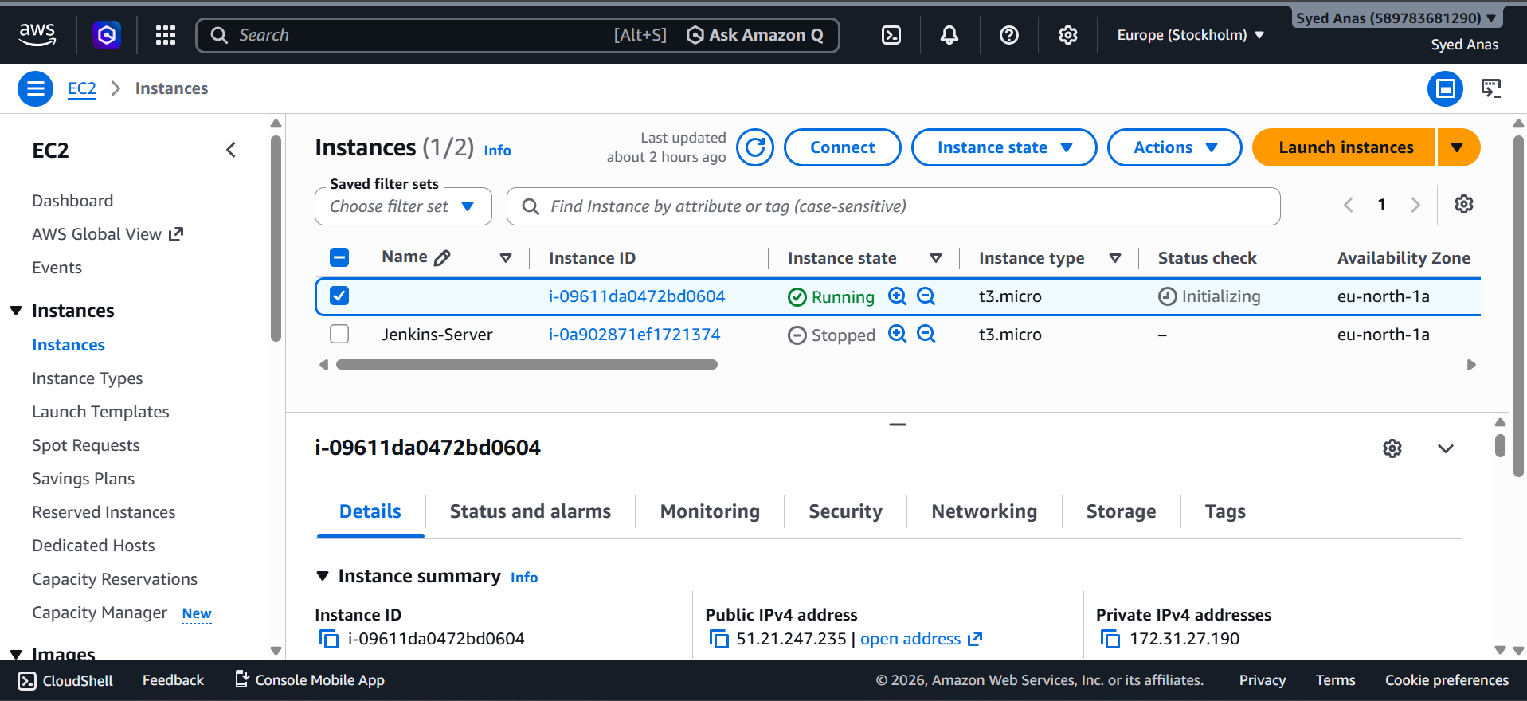
Step 2: Connect to the EC2 instance using SSH.
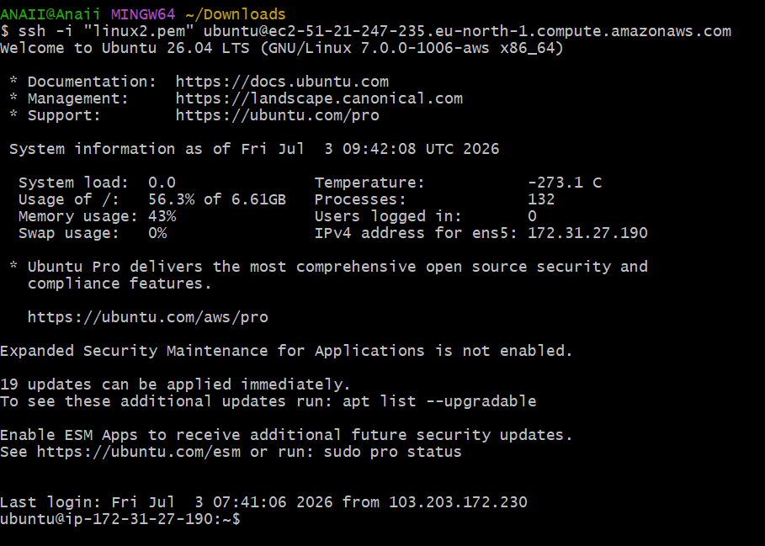
Step 3: Verify the operating system and create the Bash-Assignment project folder.
Commands:
cat /etc/os-release
mkdir Bash-Assignment
cd Bash-Assignment
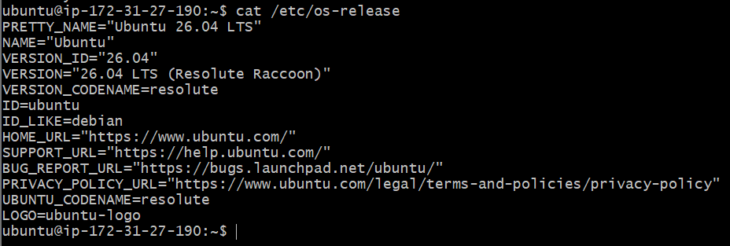
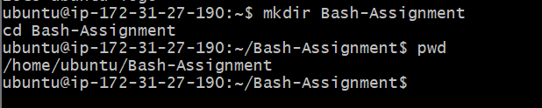

Validation
Verify SSH connectivity, operating system details, and project directory creation.

Explanation
This environment is used for every Bash scripting task. It provides a secure Linux server where scripts are created, tested, and executed.

Real-Time Use Case
DevOps engineers provision Linux servers before deploying applications and automation scripts.

Common Errors and Troubleshooting
Permission denied → Use the correct key pair.
SSH timeout → Allow port 22 in the Security Group.
Command not found → Verify package installation.

Task 1: Check if Directory Exists

Outcome
Successfully completed the task: Check if Directory Exists.

Objective
To implement and understand Check if Directory Exists using Bash scripting.

Implementation
Describe the exact commands and script used for this task.
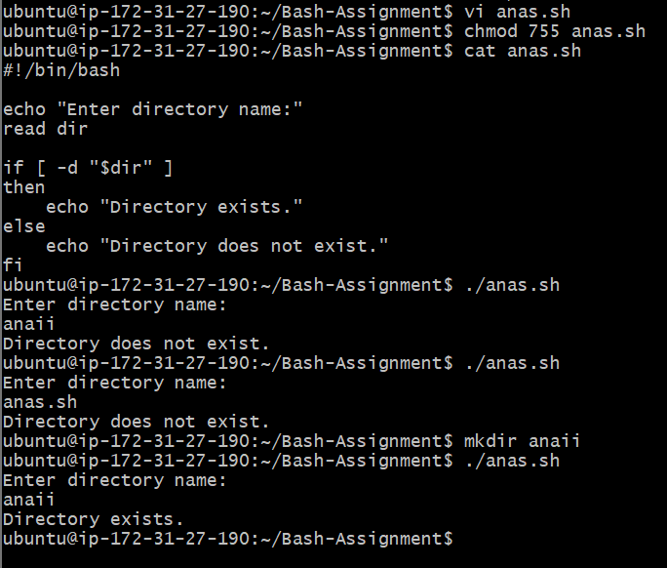

Validation Steps
Verify the expected result and include the validation command/output.

Explanation
Explain what the script does, why it is used, and its importance in DevOps (1–2 paragraphs).

Real-Time Use Case
Mention how this task is used in production or enterprise environments.

Common Errors and Troubleshooting
List any errors encountered, their causes, and the resolution.

Task 2: Create Multiple Files

Outcome
Successfully completed the task: Create Multiple Files.

Objective
To implement and understand Create Multiple Files using Bash scripting.

Implementation
Describe the exact commands and script used for this task.
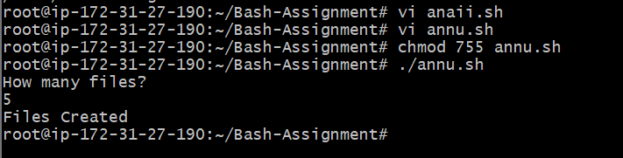

Validation Steps
Verify the expected result and include the validation command/output.

Explanation
Explain what the script does, why it is used, and its importance in DevOps (1–2 paragraphs).

Real-Time Use Case
Mention how this task is used in production or enterprise environments.

Common Errors and Troubleshooting
List any errors encountered, their causes, and the resolution.

Task 3: Take Backup of a Directory

Outcome
Successfully completed the task: Take Backup of a Directory.

Objective
To implement and understand Take Backup of a Directory using Bash scripting.

Implementation
Describe the exact commands and script used for this task.
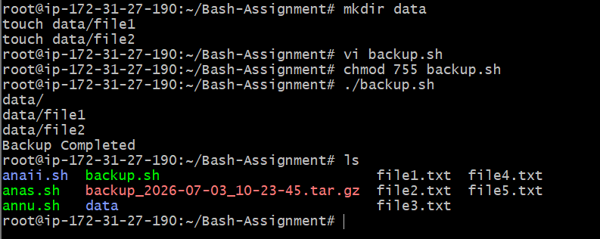

Validation Steps
Verify the expected result and include the validation command/output.

Explanation
Explain what the script does, why it is used, and its importance in DevOps (1–2 paragraphs).

Real-Time Use Case
Mention how this task is used in production or enterprise environments.

Common Errors and Troubleshooting
List any errors encountered, their causes, and the resolution.

Task 4: Install Nginx

Outcome
Successfully completed the task: Install Nginx.

Objective
To implement and understand Install Nginx using Bash scripting.

Implementation
Describe the exact commands and script used for this task.
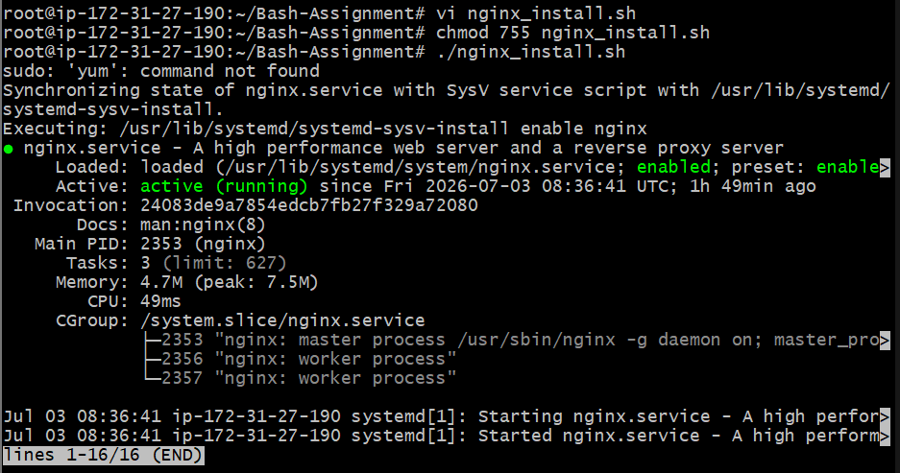

Validation Steps
Verify the expected result and include the validation command/output.

Explanation
Explain what the script does, why it is used, and its importance in DevOps (1–2 paragraphs).

Real-Time Use Case
Mention how this task is used in production or enterprise environments.

Common Errors and Troubleshooting
List any errors encountered, their causes, and the resolution.

Task 5: Install Apache Tomcat

Outcome
Successfully completed the task: Install Apache Tomcat.

Objective
To implement and understand Install Apache Tomcat using Bash scripting.

Implementation
Describe the exact commands and script used for this task.
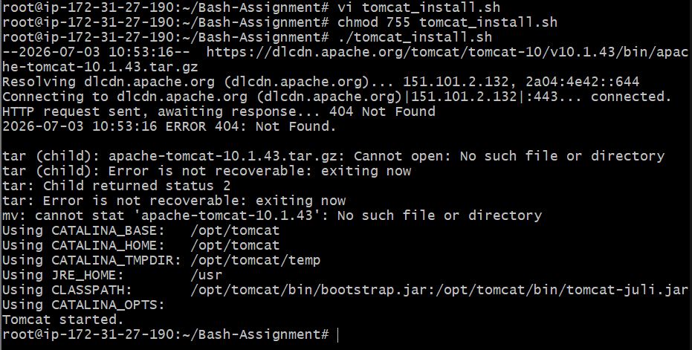


Validation Steps
Verify the expected result and include the validation command/output.

Explanation
Explain what the script does, why it is used, and its importance in DevOps (1–2 paragraphs).

Real-Time Use Case
Mention how this task is used in production or enterprise environments.

Common Errors and Troubleshooting
List any errors encountered, their causes, and the resolution.

Task 6: Check Nginx Service

Outcome
Successfully completed the task: Check Nginx Service.

Objective
To implement and understand Check Nginx Service using Bash scripting.

Implementation
Describe the exact commands and script used for this task.
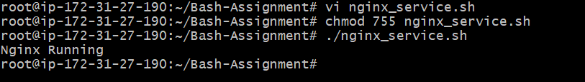

Validation Steps
Verify the expected result and include the validation command/output.

Explanation
Explain what the script does, why it is used, and its importance in DevOps (1–2 paragraphs).

Real-Time Use Case
Mention how this task is used in production or enterprise environments.

Common Errors and Troubleshooting
List any errors encountered, their causes, and the resolution.

Task 7: Calculator

Outcome
Successfully completed the task: Calculator.

Objective
To implement and understand Calculator using Bash scripting.

Implementation
Describe the exact commands and script used for this task.
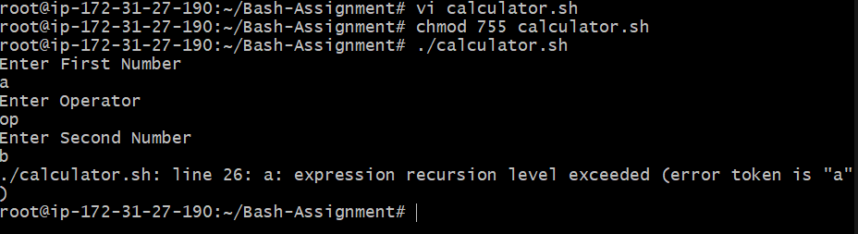

Validation Steps
Verify the expected result and include the validation command/output.

Explanation
Explain what the script does, why it is used, and its importance in DevOps (1–2 paragraphs).

Real-Time Use Case
Mention how this task is used in production or enterprise environments.

Common Errors and Troubleshooting
List any errors encountered, their causes, and the resolution.

Task 8: Create Directory if Not Exists

Outcome
Successfully completed the task: Create Directory if Not Exists.

Objective
To implement and understand Create Directory if Not Exists using Bash scripting.

Implementation
Describe the exact commands and script used for this task.
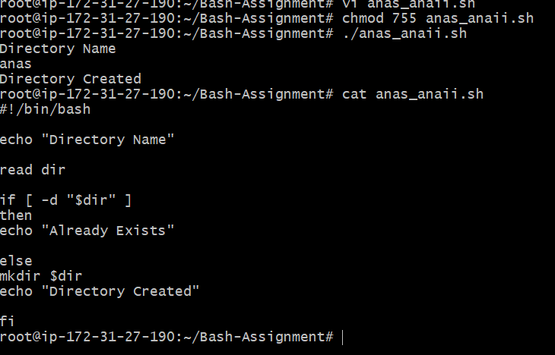

Validation Steps
Verify the expected result and include the validation command/output.

Explanation
Explain what the script does, why it is used, and its importance in DevOps (1–2 paragraphs).

Real-Time Use Case
Mention how this task is used in production or enterprise environments.

Common Errors and Troubleshooting
List any errors encountered, their causes, and the resolution.

Task 9: Delete Last 3 Lines of a File

Outcome
Successfully completed the task: Delete Last 3 Lines of a File.

Objective
To implement and understand Delete Last 3 Lines of a File using Bash scripting.

Implementation
Describe the exact commands and script used for this task.
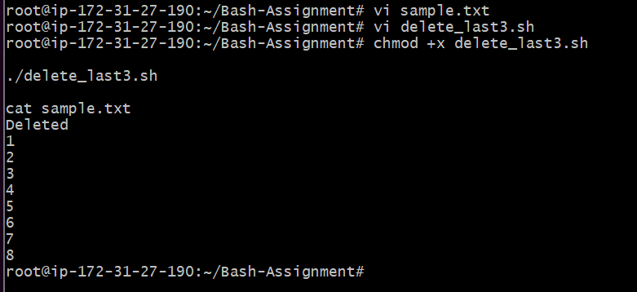

Validation Steps
Verify the expected result and include the validation command/output.

Explanation
Explain what the script does, why it is used, and its importance in DevOps (1–2 paragraphs).

Real-Time Use Case
Mention how this task is used in production or enterprise environments.

Common Errors and Troubleshooting
List any errors encountered, their causes, and the resolution.

Task 10: CPU Monitoring

Outcome
Successfully completed the task: CPU Monitoring.

Objective
To implement and understand CPU Monitoring using Bash scripting.

Implementation
Describe the exact commands and script used for this task.
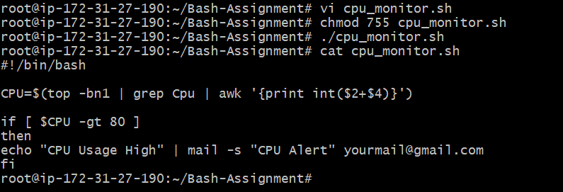

Validation Steps
Verify the expected result and include the validation command/output.

Explanation
Explain what the script does, why it is used, and its importance in DevOps (1–2 paragraphs).

Real-Time Use Case
Mention how this task is used in production or enterprise environments.

Common Errors and Troubleshooting
List any errors encountered, their causes, and the resolution.

Task 11: Disk Space Monitoring

Outcome
Successfully completed the task: Disk Space Monitoring.

Objective
To implement and understand Disk Space Monitoring using Bash scripting.

Implementation
Describe the exact commands and script used for this task.
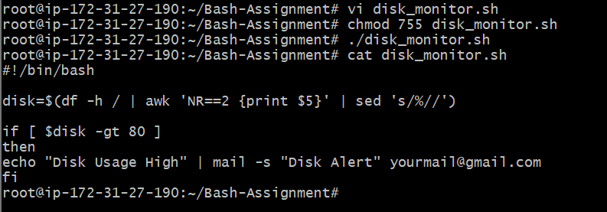

Validation Steps
Verify the expected result and include the validation command/output.

Explanation
Explain what the script does, why it is used, and its importance in DevOps (1–2 paragraphs).

Real-Time Use Case
Mention how this task is used in production or enterprise environments.

Common Errors and Troubleshooting
List any errors encountered, their causes, and the resolution.

Task 12: Memory Monitoring

Outcome
Successfully completed the task: Memory Monitoring.

Objective
To implement and understand Memory Monitoring using Bash scripting.

Implementation
Describe the exact commands and script used for this task.
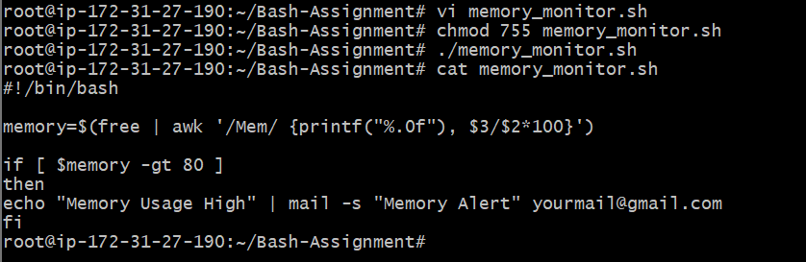

Validation Steps
Verify the expected result and include the validation command/output.

Explanation
Explain what the script does, why it is used, and its importance in DevOps (1–2 paragraphs).

Real-Time Use Case
Mention how this task is used in production or enterprise environments.

Common Errors and Troubleshooting
List any errors encountered, their causes, and the resolution.

Task 13: Crontab Exercises

Outcome
Successfully completed the task: Crontab Exercises.

Objective
To implement and understand Crontab Exercises using Bash scripting.

Implementation
Describe the exact commands and script used for this task.
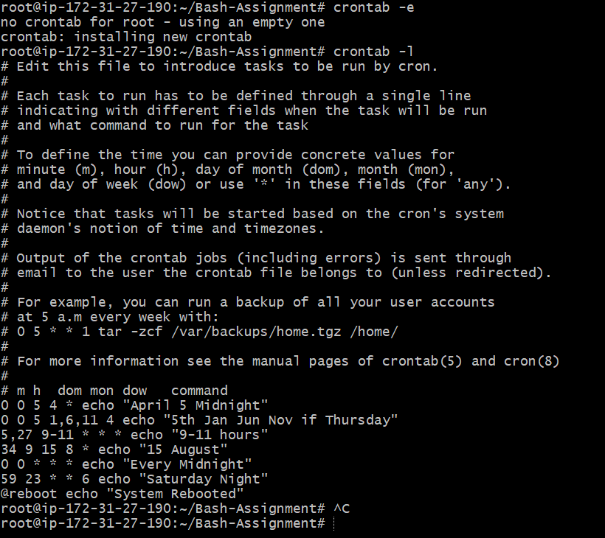

Validation Steps
Verify the expected result and include the validation command/output.

Explanation
Explain what the script does, why it is used, and its importance in DevOps (1–2 paragraphs).

Real-Time Use Case
Mention how this task is used in production or enterprise environments.

Common Errors and Troubleshooting
List any errors encountered, their causes, and the resolution.

Task 14: Push Scripts to GitHub

Outcome
Successfully completed the task: Push Scripts to GitHub.

Objective
To implement and understand Push Scripts to GitHub using Bash scripting.

Implementation
Describe the exact commands and script used for this task.
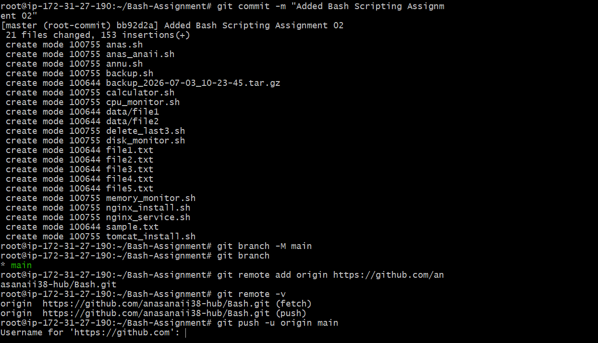
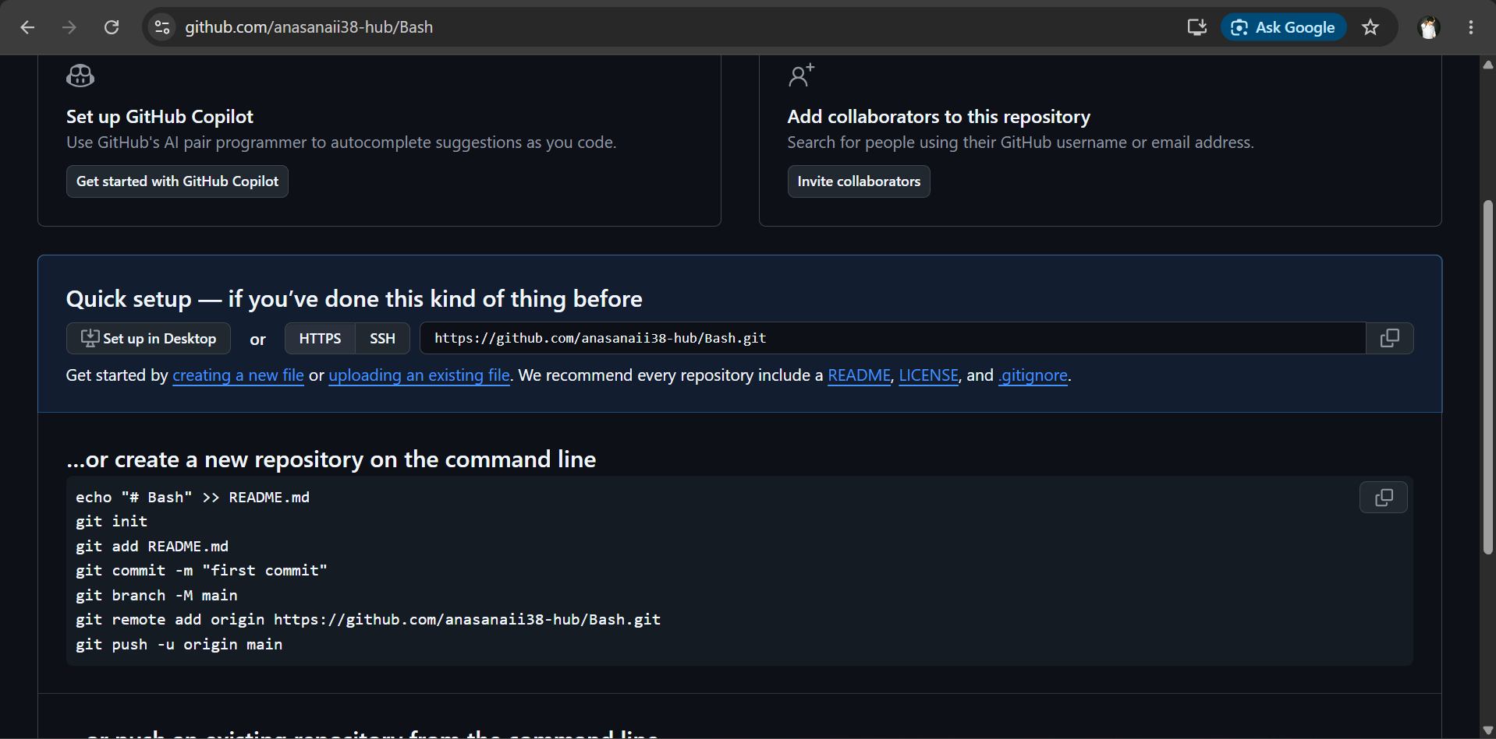
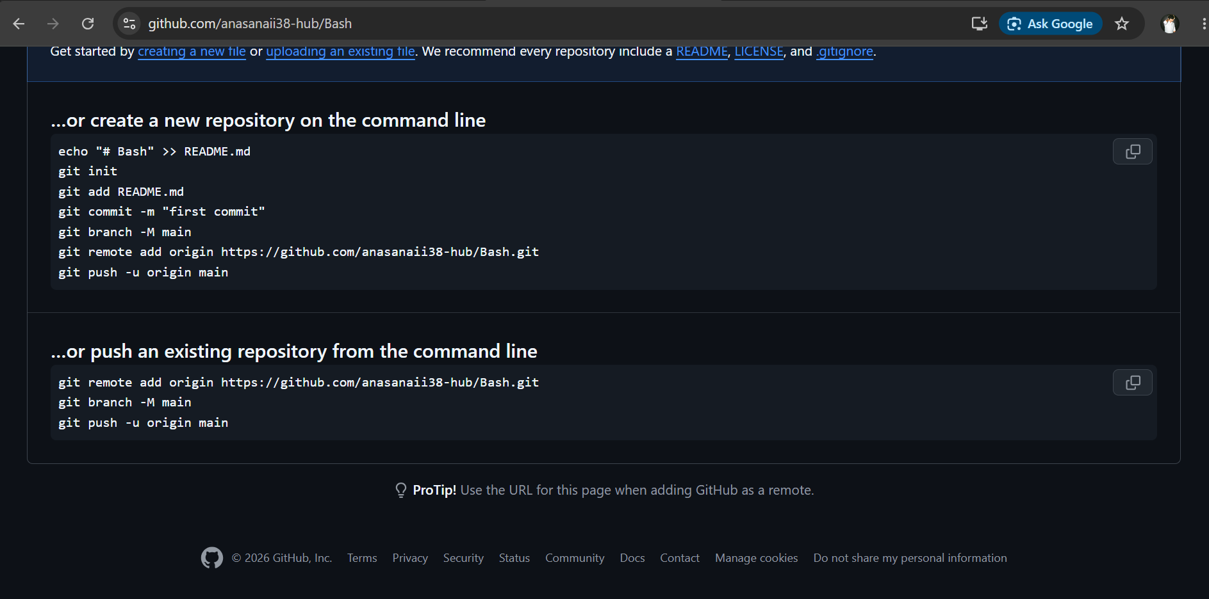

Validation Steps
Verify the expected result and include the validation command/output.

Explanation
Explain what the script does, why it is used, and its importance in DevOps (1–2 paragraphs).

Real-Time Use Case
Mention how this task is used in production or enterprise environments.

Common Errors and Troubleshooting
List any errors encountered, their causes, and the resolution.

